Alaska Anthropological Association
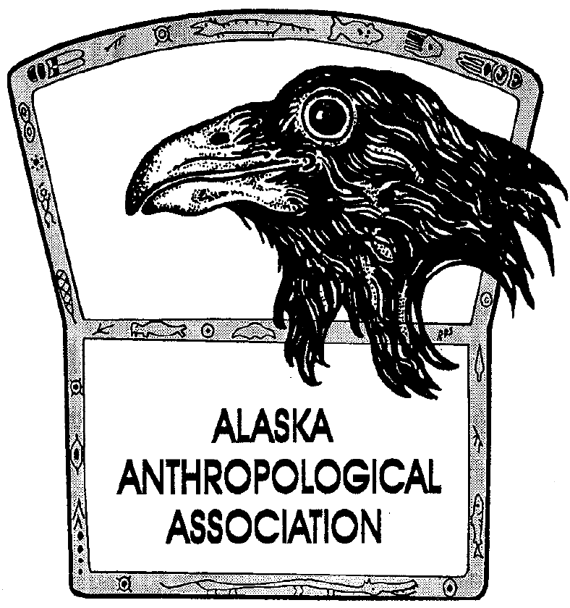
P. O. Box 241686
Anchorage, AK 99524-1686
www.alaskaanthropology.org

Board Meeting Minutes March 9, 2023

Call to order: 3:05pm

Attendance: Sam Coffman (outgoing Pres), Shina DuVall (VP), Britteny Howell (outgoing sec), Scott Shirar (scholarships), Joshua Lynch (outgoing pubs), Ruby Fried, Emilie Springer, Caroline Ketron, Laura Stelson.
Absent: Marine Vanlandeghem (external affairs).

Minutes:
- Scott Shirar was nominated by Shina and seconded by Ruby for president. Sam took a board vote, which passed unanimously via article 4 section 2 of the by-laws. Scott Shirar is the new president of the Alaska Anthropological Association.
- Ruby volunteered for secretary, Emilie volunteered for publications, and Shina will remain vice president.
- After more information, Laura volunteered for external affairs and Caroline selected scholarships.
- Each outgoing board member will connect with their new replacement to switch over email accounts, passwords, etc.
- The next board meeting will be on April 6 at 11am.
Meeting adjourned at 3:21pm

