Alaska Anthropological Association
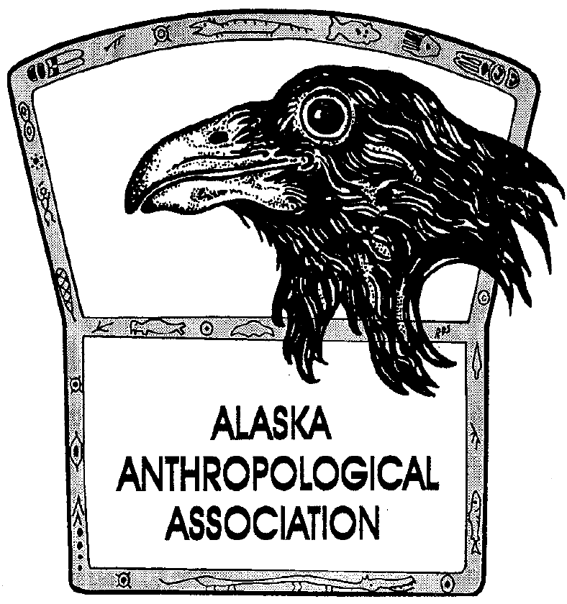
P. O. Box 241686
Anchorage, AK 99524-1686
www.alaskaanthropology.org

Board Meeting Minutes November 17, 2022

Call to order: 11:48am

Attendance: Sam Coffman (Pres), Shina DuVall (VP), Scott Shirar (scholarships), Joshua Lynch (pubs).
Guest: Jeremy Karchut (FWS).
Absent: Marine Vanlandeghem (external affairs), Britteny Howell (sec).
Minutes:

Conference
Per Jeremy Karchut: Sheraton Hotel has agreed to set aside a block of rooms, no obligation. Will provide link. Rate is $220/night.
Conference registration is open. Link is on website.
Sam sent something to Marine but not yet posted to FB, so Sam will post.
Advertising. Will really ramp up efforts for ads and sponsors here in the coming weeks.
Early bird registration until mid-December (12/17) and then rates will increase thereafter. Might extend depending on numbers.
Jeremy is still waiting for Bob Sam’s photo and bio. Will get added to website ASAP.
Josh – conference question: are they planning any 2-minute sessions? Ask Jeremy to contact Jenny Blanchard. We agree it’s a fun and worthwhile activity.
Sam has reached out to ACZ for their workshop. They may plan to do it at UAA. Changing of the guard right now. More to come on this.
Also reached out to Jeff Weinberger re AHRS work group that Wednesday of the conference. More to come on this.
Scholarships
Scott – no scholarship applications yet. Sam will post to FB if Marine doesn’t reply.
Overall just get the word out!
Membership Issues
No major complaints/feedback on Membership Rate increase. Feel like explanation in newsletter was reasonable and understandable.
Just received from Carla Fernandez our Council of Allied Societies membership with SAA. It is $35. We agree that it is something we want to renew. Scott motions to renew, Shina seconds. All in favor. The motion passes.
Website Updates
Email from Billy with costs. Considering tabling this for now but consider upgrade for Stripe. 8 hours of time = $760 to do this. Sam will check with Billy about whether and when this function will stop working on the site and follow up with the Board.
Publication Updates
Josh – has not heard back yet from EBSCO rep. Typical. Not surprised. But did get another couple of orders. For a physical version…
Newsletter Updates
Newsletter slated for mid-December – get Angela Gore info for this. Sam and Angela have put together QR codes to register for the conference to be placed in the newsletter.
Board Elections
Four months until positions on the Board have changed. Sam asks that we review our Board position duty descriptions and update them. Add new tasks or provide edits. Send them to Sam or the group.
Budget
2021 budget review. Sam and Ann discussed the budget a while back to correct errors on the budget balance sheet. They did remedy some of that. A lot due to the Vanguard account losses. Going over line items in red (total income). Ann has been very generous with her contribution to our budget management and accounting. Board might consider giving her an award of recognition at the end of the year.
Proposed scheduling a 45-minute session with Ann to go over and clarify questions about FY2021 budget. There are some figures that we don’t understand. Will ask her to be present for next month’s meeting to walk us through these figures.
If calculations are correct, we are close to what we projected for the FY21 budget.
Can still work on approving the FY 2023 budget today.
In far left column, Sam has put together a tentative FY23 budget. Board reviewed this proposed budget line by line.
Josh asked the question about the consequences of going totally digital with publications. Sam suggested a survey monkey questionnaire. Invite membership to weigh in on this idea. Sam – suggests asking “What’s most important to the membership that the association offers?” When you receive the AJA, what do you do with it?
Suggest first running this idea by Ken and Bryan. Sam and Josh will do this in January. Scott: The key is going to be having the editors on board. Sam and Josh have discussed having a dedicated website for AJA.
Sam: Other thoughts on budget? Josh thinks it looks consistent with other past years’ budgets.
Shina motioned to board-approve the proposed FY2024, Scott seconded and all voted in favor on 11/17. Membership to vote on 3/4/23.
Sam will post some updates on the conference to Facebook.
Next meeting is 12/15 at noon.
Josh motioned to adjourn, Scott seconded. All in favor.
Adjourned at 1:22pm.

