Alaska Anthropological Association
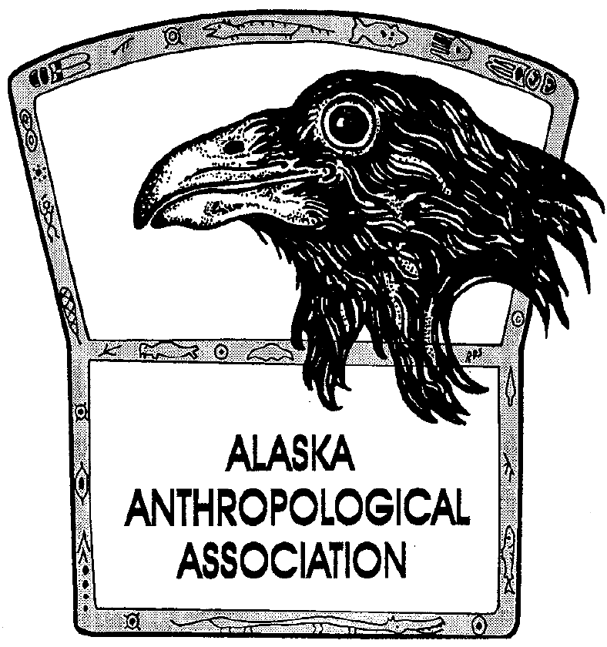
P. O. Box 241686
Anchorage, AK 99524-1686
www.alaskaanthropology.org

Board Meeting Minutes September 15, 2022

Call to order: 12:02pm

Attendance: Sam Coffman (Pres), Shina DuVall (VP), Britteny Howell (Sec), Scott Shirar (scholarships), Marine Vanlandeghem (external affairs).
Guest: Jake Adams.
Absent: Joshua Lynch (pubs).

Minutes:

Update on conference (Jake) – Two keynote speakers booked (Bob Sam – Tlingit, Jennifer Raff – bio anthropologist). Sam will give more info on how to cover their travel and per diem.
- The posters are being created right now and will be included in the conference bags. Jake will ask if we can work the poster art into the cover of our conference programs.
- Their office is finalizing the meal options with catering and will let us know when its all ready.
- They’ll also reach out to “Visit Anchorage” for swag to include in the conference bags.

Conference fundraising
- Sam will reach out to Dowell for getting ads together for the conference program.
- Shina will assist Sam with reaching out to groups, agencies, and people for fundraising.

Updating the website
- Sam has made some updates to include the conference information we have, to date.
- Scott will update all the awards and scholarship due dates.
- Marine will put the conference into on Facebook.

Upcoming newsletter
- Sam has submitted blurb to notify membership of our rate increases. He will also send an email explaining the rate increase out to all.
- Angela is finalizing this month’s newsletter to go out tomorrow.
- We are now officially on Pick Click Give, which will also show up in the newsletter.

Financials

Adjourned:

