Alaska Anthropological Association
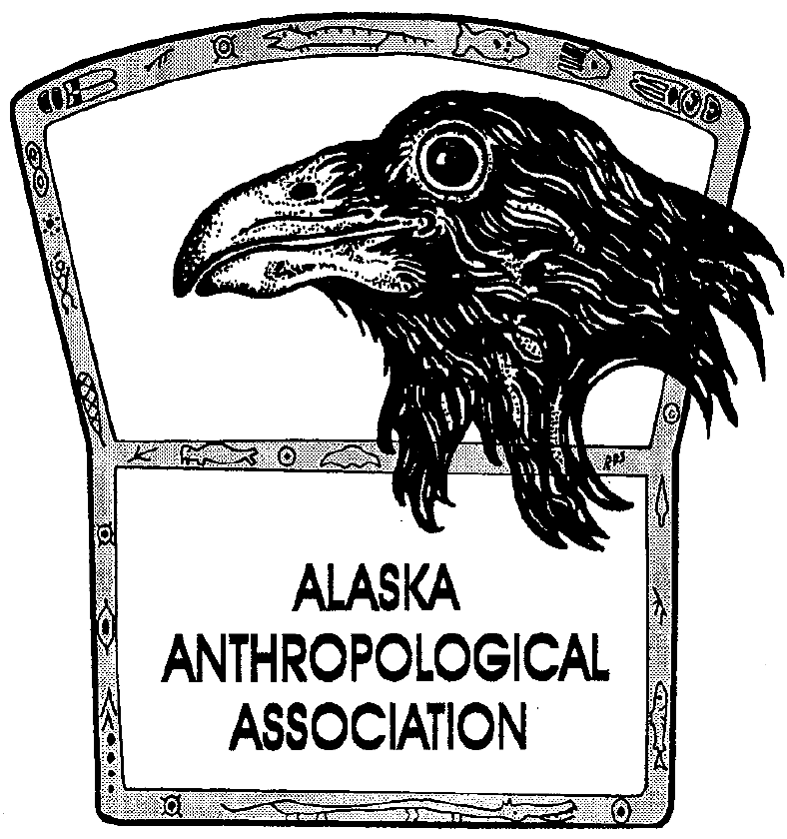
P. O. Box 241686
Anchorage, AK 99524-1686
www.alaskaanthropology.org

Board Meeting Minutes February 10, 2022

Call to order: 12:02pm

Attendance: Sam Coffman (Pres), Shina DuVall (VP), Britteny Howell (Sec), Scott Shirar (scholarships), Marine Vanlandeghem (external affairs).

Minutes:
- Financials
  - Sam led us through a review of the balance sheet and the profit & loss documents. He is also preparing the financials for the AkAA annual business meeting.
  - Ann asks board “If I go back to 10-1-2020, the student scholarship donations = 1525.00 and expenditures were 5500.00, Conference donations = 1000.00, expenditures = 5764.99, and the publications I'm really not sure what you want in the savings account, since member dues cover some of the cost of the pubs, in addition to the donations to the publication fund. I can transfer a portion of each member's annual dues into the pub savings account, but you need to tell me what % of their $50, $100, $150, $165 would need to be transferred.”
  - Britteny moves and Scott seconds to set aside 50% of membership dues to be transferred to the publication savings account. Motion passes.
- 2021 taxes
  - Ann submitted documents to our tax accountant, Rod, to file our 2021 taxes.
  - No update on our 2019 taxes.
- 2022 conference update
  - Josh – we are 2 weeks away! Everything looks good, using google docs for our agenda. Still need talk title from 2nd keynote speaker. Have a practice session set for presenters to get familiar with presenting via zoom.
  - Shina and Marine update the board on the career panel.
- Election comment
  - Britteny - -currently have 38 votes (27% of membership). Closes on Feb 17.
- Scholarship update
  - Scott – received and sent out applications to committee that are getting scored and commented upon right now.
  - Sam requests that Scott submit a google doc of scores to the board when they have finished. Board plans to vote via email when we receive that document to finalize payment to those recipients. Will get it next Tuesday.
- New student intern
  - Sam – Benjamin finishes his term end of March and plans to go to graduate school. A UAA student is interested and Sam will follow-up so they can start at the end of March.
- Future Conferences
  - Shina – Working with Jeremy on 2023 venues (looking at downtown).
  - Who should host 2024 conference? Sam and Shina starting to think about that.
- Pick-Click-Give
  - Sam – it opened Feb 1 for the current PFD year but the association needs to pursue getting on the list of orgs for 2023.
- Board updates – All
  - Shina – Jeff dropped off extra archaeology month posters that weren’t distributed in the past. She will write up something for the conference program to give the posters away to membership. Volunteers to double-count the votes after Britteny does.
  - Josh – publication still getting EBSCO requests, need to track down some physical copies of a past version, haven’t heard an update from Benjamin (100 copies are missing).
  - Marine – Asked Bill to update website for student membership option, but no response. Sam will follow-up.
  - Scott – We need an image or logo about climate change for the cover of our conference program.
Meeting adjourned at 12:54pm

Addendum: February 18 the board voted via email to accept the slate of award and scholarship winners selected by the committee. Motion was made by Britteny, seconded by Shina and passed.

