Alaska Anthropological Association
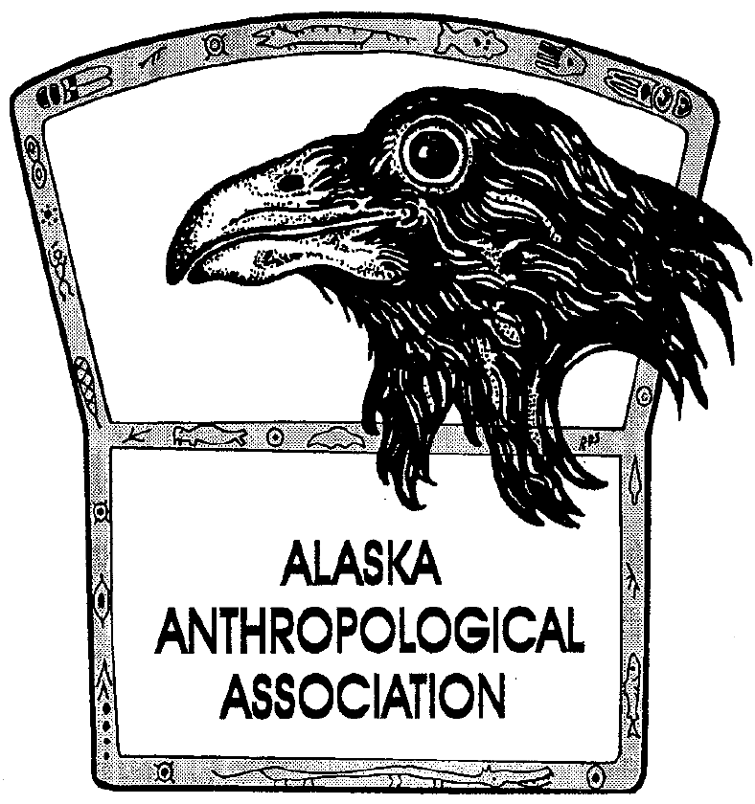
P. O. Box 241686
Anchorage, AK 99524-1686
www.alaskaanthropology.org

Board Meeting Minutes January 13, 2022

Call to order: 12:05pm

Attendance: Sam Coffman (Pres), Shina DuVall (VP), Britteny Howell (Sec), Ann Biddle (Treas), Marine Vanlandeghem (external affairs), Scott Shirar (scholarships).

Minutes:
- Financials - Sam/Ann
  - The Vanguard amount in the P&L sheet reflects the value in that account as of today.
  - The $90 charge in “website” is for our annual maintenance.
  - We have two segments (totaling $1400) in our vanguard for equipment and website upgrades that the board decided to move into “unrestricted funds,” Shina moved, Britteny seconded, passed unanimously.
- 2019 Tax update – Sam
  - No updates.
- Update on creation of new savings accounts at Alaska USA - Sam
- Board election update – Britteny
  - There are three nominations so far, ballots will go out Monday, Jan 24.
- 2023 Conference Update – Sam
  - Sam moves to approve Jeremy Karchut at Fish and Wildlife as the conference organizer for next year, seconded by Shina, board approves unanimously, to occur in Anchorage.
- 2022 Conference Update – Josh
  - Moving forward smoothly! We have the “schedule in advance” together and can be reviewed by board before posting to website/social media next week.
  - They have three possible keynotes to include in the conference this year.
- Board updates
  - Marine – how do we move forward with the new $25 student membership rate? Britteny said to contact Billy Finley to have the website updated with this additional option.
  - Saturday is the awards and scholarships deadline, we have one scholarship application and no award nominations. Spread the word!
Meeting adjourned at 12:45pm

