Alaska Anthropological Association
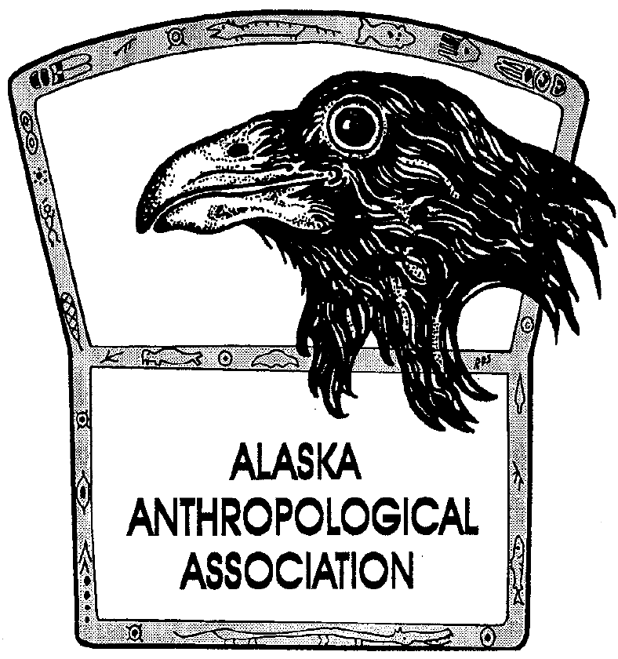
P. O. Box 241686
Anchorage, AK 99524-1686
www.alaskaanthropology.org

Board Meeting Minutes August 19, 0221

Call to order: 12:03pm

Attendance: Sam Coffman (Pres), Shina DuVall (VP), Britteny Howell (Sec), Scott Shirar (scholarships), Marine Vanlandeghem (EA), Joshua Lynch (publications).

Minutes:

- #AkAA Virtual 2022 letter for organizing committee
  - Group edited and finalized the letter for Shina to send out
  - Board moves (and passes) for free member attendance and $20 fee for non-members
- Atlatl giveaway
  - Original post and reminder Facebook posts have been made
  - Still seeking photo entries!
- Newsletter contributions
  - Due September 1
- Updates from board members
  - Increasing the order size of AJA print copies by at least 100
  - Shina will meet with Ken, Ann, and the publisher about this
- Financials
  - Sam and Ann will meet about transferring Vanguard funds to an accessible side account to help cover expenses
- Next meeting September 15 at noon
Meeting adjourned at 12:35pm

