Alaska Anthropological Association
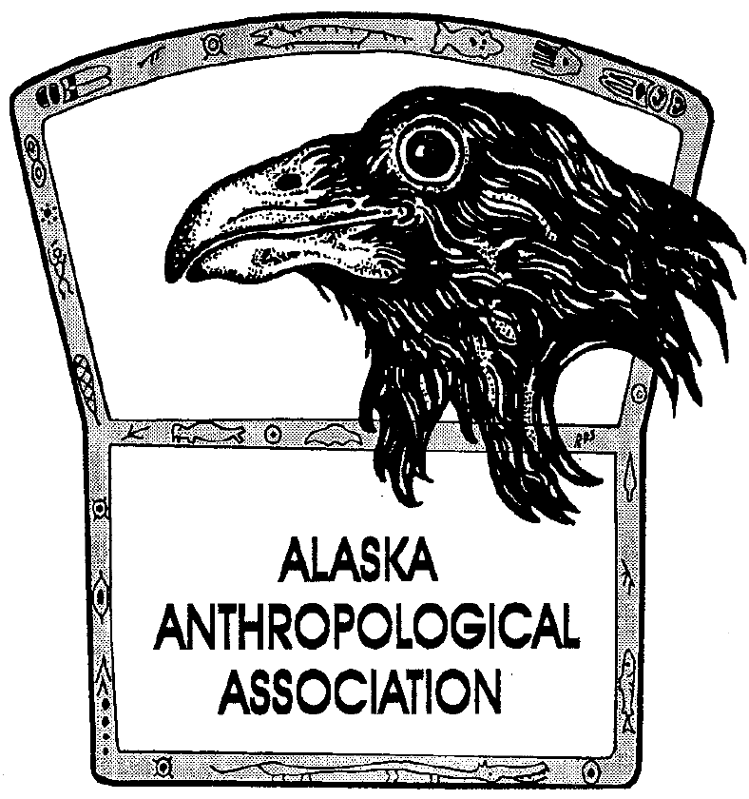
P. O. Box 241686
Anchorage, AK 99524-1686
www.alaskaanthropology.org

Board Meeting Minutes June 25, 0221

Call to order: 12:01pm

Attendance: Sam Coffman (Pres), Shina DuVall (VP), Britteny Howell (Sec), Scott Shirar (scholarships), Joshua Lunch (publications). Excused: Marine Vanlandeghem (EA)

Minutes:
Association YouTube Channel
- Email went out to membership, now have 14 subscribers.
- Shina will work with Oregon archaeological society for advice on how we can enhance our channel’s visibility.
- Britteny will post a link to our YouTube channel on Facebook.
Newsletter content
- End of September issue, board members should each submit an item to Angela.
- Include an item on the culture camp, field school, and other ideas were suggested.
Pick Click Give listing
- $250/year to be listed in March 2022.
- Will need a lot of marketing in order to make out money back, but it is worth trying.
- Will vote at July 2021 meeting.
Finances

- 2019 federal tax notice that we filed late and owe $3,072.27.
- Ann thought she had filed an extension but our tax preparer was not sure that got filed and has requested the fee be waived.
- We are in process of filing out 2020 taxes.

2022 Annual Conference
- Conversation continues from last month to consider a virtual conference again this year, plan local events in communities like happy hour and lectures, then do a bigger in-person conference next year.
- Shina moves and Britteny seconds the motion for a virtual 2022 conference, vote passes unanimously.
- Shina will make a call to membership via email for interested parties to join the conference planning committee that will be partially staffed by board members.
Next meeting will be July 22 at noon.

Meeting adjourned: 12:50pm

