Alaska Anthropological Association
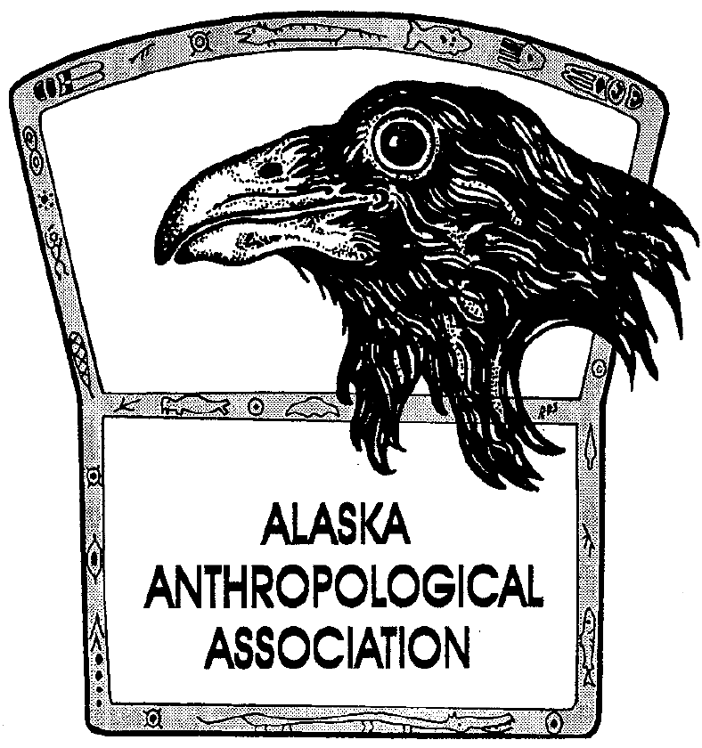
P. O. Box 241686
Anchorage, AK 99524-1686
www.alaskaanthropology.org

Board Meeting Minutes April 8, 0221

Call to order: 12:08pm

Attendance: Sam Coffman (Pres), Shina DuVall (VP), Britteny Howell (Sec), Marine Vanlandeghem (EA)

Minutes:
#AkAA Virtual 2021 conference
- Should we start YouTube channel, and get Zoom Recordings from conference edited and uploaded? Sam suggests we bring this to a board vote for May meeting because it will be a digital platform for future board members to maintain into the future.
- Shina suggests there might be information about sites, individuals, and cultural groups that was inadvertently shared and needs to be edited out of the videos before posting. Shina and Marine will take first look at the editing of the videos in the Dropbox, and Sam will ask conference committee if anyone wants to help with video editing tasks.
April is AK Archaeology Month
- "Stone '' poster on Facebook and website.
- Sam: Lets have voting for archaeology photo submissions on Facebook and give-away an atlatl (1st prize), with 2nd and 3rd place prizes that consist of a package of the last 3 years of archaeology month posters. Marine will coordinate and handle the contest on Facebook.
Association Finances
- No board financial sheets were sent this month, so Sam reviewed latest bank transactions.
- Received $500 donation for scholarships and publications.
- Sam will look into adding “Pick Click Give” option for the board, maybe bring to full membership vote at next conference, since there is a $250 fee each year.
Climate Change Committee
- Idea to start an “impacts on coastal erosion and archaeology committee.”
- Shina will speak with Anne Jenson about her ideas and thoughts about what this would look like and how to get started.
New Scholarship of Equity
- Begin fundraising and send call for fundraising for this new scholarship. Need to name it and come up with criterion for its purpose, who will qualify, etc.
- We will need $25,000 in order to create an account that will make this scholarship self-sustaining via interest.
Spring 2021 Newsletter
- Board member contributions to Angela Gore by April 23 (angkgore@gmail.com).
- Marine will also solicit newsletter items via Facebook.
AkAA Conference 2022
- Location, virtual, in-person, hybrid? Sam will check with Valdez to see if they are still interested in hosting.
- Can touch-base in May meeting about ideas and suggestions. Sam has asked if UAA and UAF will jointly host a virtual conference.
- Consider having our 50 year anniversary meeting in Anchorage in 2023.
Meeting adjourned: 12:59pm

