Alaska Anthropological Association
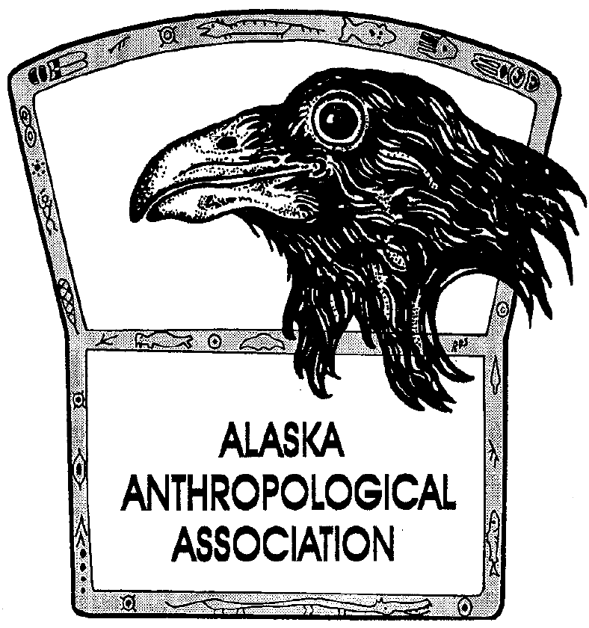
P. O. Box 241686
Anchorage, AK 99524-1686
www.alaskaanthropology.org

Board Meeting December 12th, 2018

In attendance: Kory, Julie

- AAA Internship (Julie) – One application received from Liz Ortiz.

- AJA 16(2) (Julie) – At the printers, half paid. Discussed that Institutional orders of journal (through EBSCO) are often placed at the end of the year rather than beginning of the year. This creates difficulties in ensuring we have the journals to cover orders after the fact.

- John Cook Scholarship (Julie) - $25k check being sent to AAA from Elizabeth Cook from John’s estate. This is intended for a student travel award.

- Scholarships (Julie) – By due date we have received one Award nomination for Outstanding Current Contribution, one Lobdell scholarship, one Ludwig scholarship, one VanStone scholarship and five travel grants.

- Update on Board Nominations (Kory) – talk to Sam about getting bios out in newsletter?

Nominations for Board Member:
Britteny Howell – have bio
Thomas Allen – have bio
Sam Coffman – need bio
Morgan Blanchard – need bio

Student Board Member:
Joshua Lunch – have bio
Dougless Skinner – need bio
Rachel Turner – have bio
Norma Johnson – waiting on confirmation of interest
Peter Ellis – waiting on confirmation of interest

