Alaska Anthropological Association
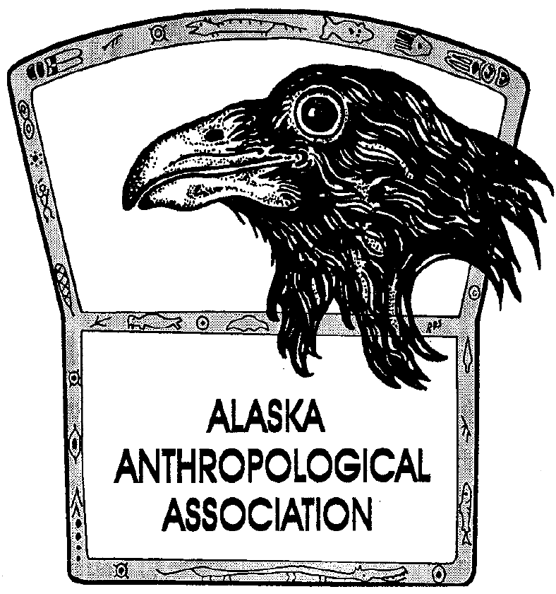
P. O. Box 241686
Anchorage, AK 99524-1686
www.alaskaanthropology.org

Annual Business Meeting
March 30, 2017
Westmark Fairbanks, 3pm

Notes of the annual Business meeting:

- New Board Members
Introductions of the new board took place. The 2017-2019 board members are President- Julie Esdale, Vice President- Amy Phillips Chan, Treasurer- Elizabeth Andrews, Scholarships and Awards- Phoebe Gilbert, Publications- Shelby Anderson, External Affairs (and student rep)- Yoko Kugo, and Secretary- Kory Cooper. Amy moved from secretary to vice president for the second year of her two year term. Phoebe stayed in her current position for the second year of her two year term. Shelby started a new two year term as an incumbent in the publications seat.

- Memberships
aaa currently has 133 Regular Members, 47 Student Members, x Lifetime Members, and 3 Institutional Members. Memberships (Total=183) are down slightly from previous years. The board proposes to start a membership drive this fall for 2018.

- Publications
- Volume 13(2) of AJA was published and mailed out
- 2016 Volume, Volume 14(1-2) is almost ready for printing
- AJA is currently accepting submissions for Volume 15 and 16. Submissions are due by March 31, 2017 for consideration for the 2017 volume.
- A new copy editor, NAME, was hired to replace Erica Hill.
- The AJA is looking for a new coeditor to help Ken Pratt.
- Erica is moving to book review editor.
- The board is working with EBSCO to hae future volumes of AJA indexed, beginning with 13(2). Indexing increases visibility of the journal to library searches and give the AJA a wider readership.
- We continue to offer open access journals that are older than 2 years old on the Association website.
- The membership would still like us to post individual articles on the website. The board agreed to look into this again. Claire Alix offered to provide us with articles that she has already split up.
- Some in the membership would like to see color photos in the online version of the website. Shelby will ask the publishers about that.
- A manuscript is scheduled for submission to Aurora at the end of 2017.
- We are looking for more manuscript submissions for both AJA and Aurora. Shelby is creating a postcard for distribution to individuals and institutions to remind them of this publication outlet.

- 2017 Scholarship Winners
- Thomas F. Eidel MA Scholarship: Kate Yeske
- Stephanie Ludwig Memorial Scholarship: Bree Doering
- Edwin S. Hall Jr. Student Paper Award: François Lanoë
- John E. Lobdell Undergrad Scholarship: Robyn Callahan

- Awards and Scholarships
- Phoebe will work this year to clarify submission rules for aaa scholarships and awards.
- There were no award nominations this year. Phoebe will form a new award committee to revitalize the program and make the process less political.
- The board will work to solicit more award nominations

- 2018 Budget
The 2018 budget was proposed (see below). The budget will be voted on by the board before September 2017.

Income
Membership Income | $19,000.00
Publication Income | $200.00
Donations | $800.00
Conference Income | $25,000.00
Conference Sponsorships | $2,500.00
Interest Income (10 year average) | $6,000.00
TOTAL | $53,500.00
Expenses
Board Expenses | $500.00
Accountant | $1,000.00
Treasurer | $5,000.00
Bank Fees | $700.00
Insurance | $750.00
Licensing | $75.00
PO Box | $450.00
Storage Unit/Dropbox | $1,525.00
Supplies | $300.00
AJA Design | $2,800.00
AJA Publisher | $6,000.00
AJA Copy Edits | $1,500.00
AJA Shipping | $200.00
Scholarships | $7,000.00
Conference Program | $3,000.00
Conference Transportation | $300.00
Conference Speakers | $5,000.00
Conference Events | $4,000.00
Conference Supplies | $1,000.00
Conference Venue | $14,000.00
Website Hosting | $400.00
PEG Archaeology Month | $2,000.00
TOTAL | $57,500.00
Net Income | -$4,000.00

- 2018/2019 Conference Locations
- The 2018 aaa meeting will be in Anchorage and organized by the NPS regional office and the Smithsonian Arctic Studies Center.
- The board is considering Nome for 2019. A team from Nome including folks from the Bering Straight Corporation, Kuwarek Corporation, and Carrie McLean Museum has offered to organize.
- Wendy Arundale expressed concerns about the cost of such a meeting limiting the number of participants able to go.
- The board needs to consider negotiating rates for plane tickets, places to stay, and places to eat.
- Travel scholarships will be a necessity

- 2017 Conference
- Thank you to the conference team from UAMN and UAF Anthropology! You did a great job.
- The meeting was on budget and even raised $1179! See below for total expenses and income:

Conference Costs
Reception room | $1,027.50
Reception Catering | $1,317.32
Speaker costs | $2,111.60
Printing | $1,673.25
Misc supplies | $1,131.44
Buses | $300.00
Westmark | $20,834.70
TOTAL | $28,395.81
Conference Income
Fees | $25,475.00
Sponsorships/Ads | $4,100.00
TOTAL | $29,575.00
BALANCE | $1,179.19

- Fundraising
- The board is trying various methods of fundraising for student scholarships. We will apply for Pick, Click, Give through the PFD program ($250) and the Fred Meyers Rewards Program
- Linda Yarborough asked if we could get an Alaska Airlines Visa Card to get air miles or have air miles donated from the membership for travel scholarships
- We should also sign up for Amazon Smile

- ACZ Update
- Organized 4 mini workshops during the fall of 2016, free to the public, students, and professionals.
- Hosted a display at International Archaeology Day with UAA in October and activities and a display at World Anthropology Day with UAA in February
- Partnered with NPS to teach Girl Scouts of America Women of Science scouts about the benefits of heritage documentation and archaeological methods, in February.
- Awarded $700.00 Christina Jensen scholarship to a doctoral student Jason Miszaniec studying Northwestern Alaska subsistence.
- Organized the “All about Teeth” Annual ACZ Workshop at this year’s aaa Annual Meeting.
- To join or questions about ACZ activities, the collection, volunteering, sharing your newest publication, please check out alaskazooarch.org and the ACZ Facebook page

- AHRS Advisory Group Update
- AHRS group is looking for an agency member.

- PEG Update
- Get your April archaeology Month Activities to Jeff_Rasic@nps.gov asap to go out with the posters and in the next newsletter
- 2016 Thule poster will be at the SAAs, vote if you are there!
- The UAF archives would like a copy of the posters

- Vanguard Account
The board will put together some proposals for spending the Vanguard account money and put them out to the membership.

- Action Items
- Fall membership drive
- Individual AJA articles on website
- Find out if it is possible to get color photos in the online edition of the AJA
- AJA submission postcard
- Scholarship and award submission revisions
- New award committee
- Award nomination drive
- Nome meeting rate research
- Travel scholarship development
- Pick Click Give
- Fred Meyers Rewards
- Alaska Air Visa research
- Sign up for Amazon Smile
- Check link to ACZ’s web page from aaa site
- Archaeology month posters to UAF archives
- Vanguard account proposals

Meeting Adjourned at 4pm

