Alaska Anthropological Association
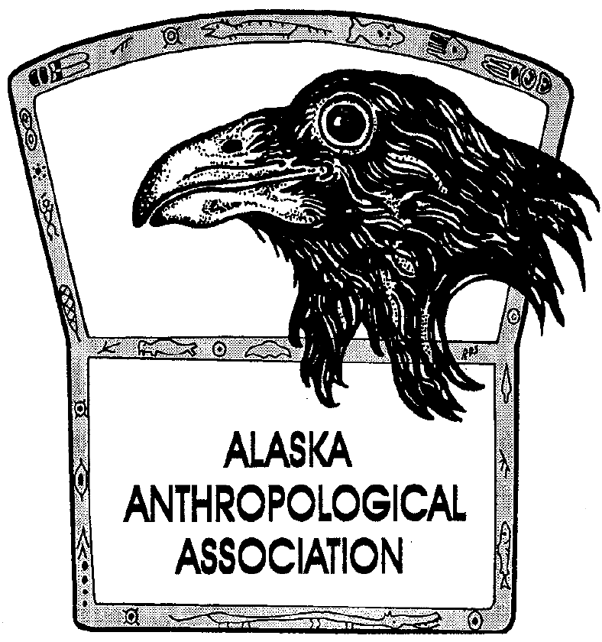
P. O. Box 241686
Anchorage, AK 99524-1686
www.alaskaanthropology.org

Board Meeting May 9, 2018

Attending: Julie, Kory, Amy, Yoko, missing Phoebe, Shelby, Vivian

- Summer Meeting Schedule- discussed. No change.

- UAA Student Internship Opportunity- Sally Carraher was supposed to call in to discuss but did not. Postpone until next meeting.

- SAA-Council of Affiliated Societies: $35 annually to join, gets a table at the SAAs for journals/post-cards. We discussed joining and decided to do so.

- Storage Unit: Cleaned up and organized back issues of journals after AAA meeting. More journals that Aron Crowell was storing were also moved to the unit. There are dozens of boxes of old journals but only the latest issues get purchased. Discussed donating full sets of journals to local libraries.

- Publications: Do old copies of journals need to go to the Library of Congress? Shelby will check on this. We discussed the possibility of linking up with JSTOR again, but it is expensive and customer service is poor. We are doing well with EBSCO and SCOPUS.

- Mileage donations: We discussed mileage donations for travel scholarships, but decided that would be administratively cumbersome and to put it on the back burner for discussion at another time.

- Archives: Hard copies of things that are online were removed from the storage unit, but older stuff was kept that is archive worthy.

- 2019 Meeting: Amy updated the board. Venues are lined up, majority of sessions will be at UAF Northwest Campus, reception at the Carrie McLain museum, working on conference workshops and activities. Two speakers confirmed – Igor Krupnik for the dinner banquet and Bernadette Yaayuk Alvanna-Stimpfle director of Eskimo Heritage Program, Inupiat Language expert, for the luncheon.

- 2020 Meeting: Still up in the air, Kari mentioned pairing with AK Native Studies Conference, talked to organizers of most recent one and they said no. Seattle may be another option? Will try Fairbanks for 2020.

- Board Positions: Think of new members for President and Student Rep.

